# How to make a backup on a USB stick

First of all we insert our USB stick into the PC and open our wallet (in our case the Monk one), then go to the bottom left and choose the settings cog.

* 1 Settings
* 2 Wallet Data
* 3 Wallet

As in the image below:

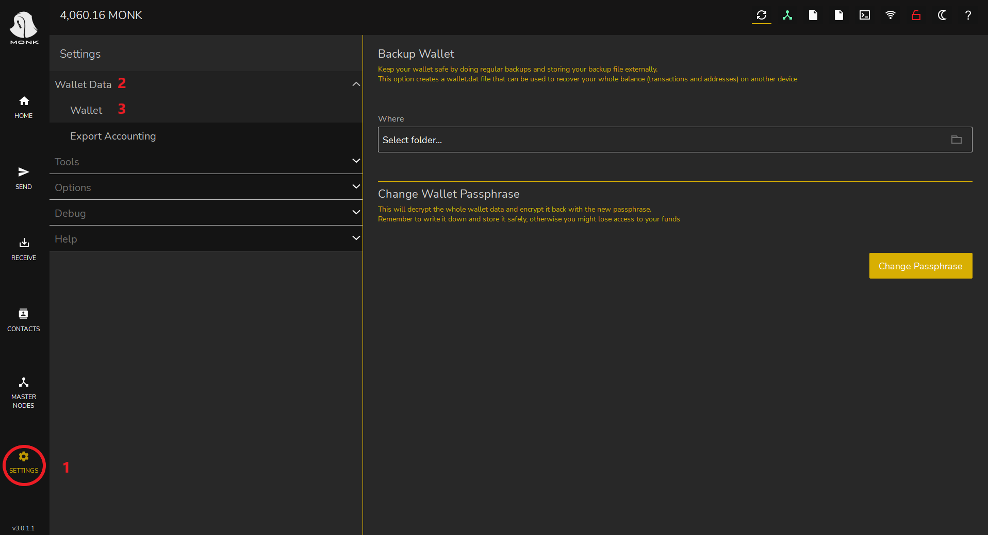

Once this is done, as you can see in the image, the backup wallet menu will open, click on the folder icon on the right as in the image below:

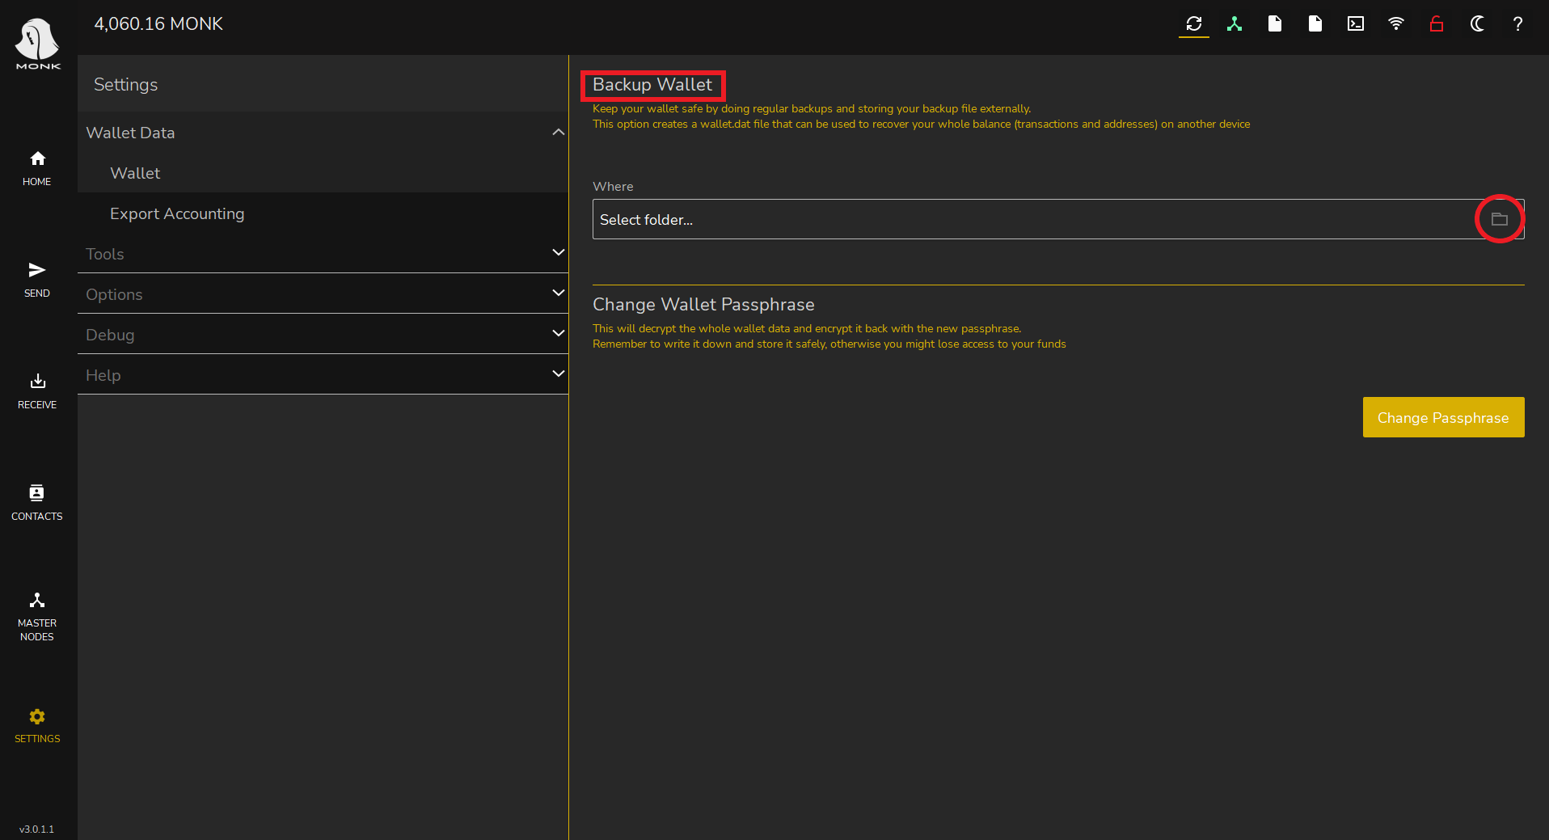

After that a window will open where we can choose the destination of our backup

* 1 look for our USB stick and click on it to select it
* 2 let's choose a name for our backup
* 3 click on save

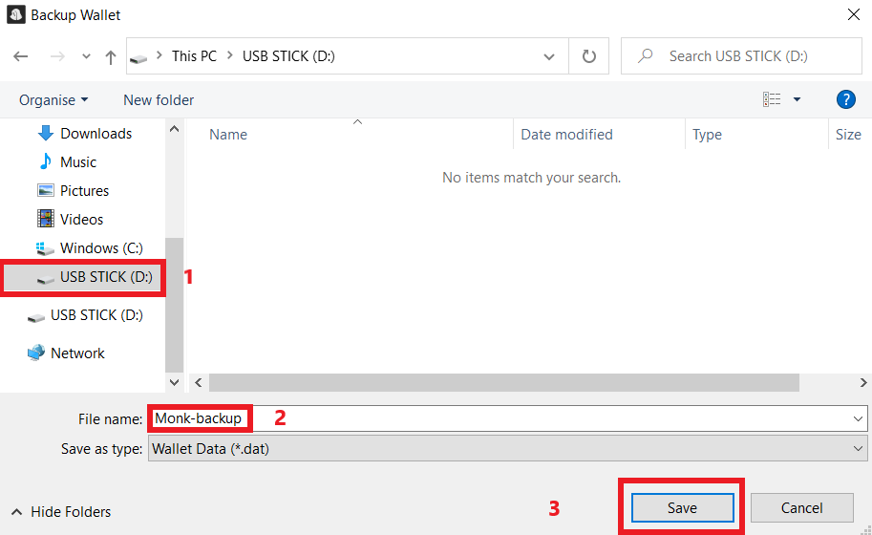

If the operation went well, this will appear:  
  
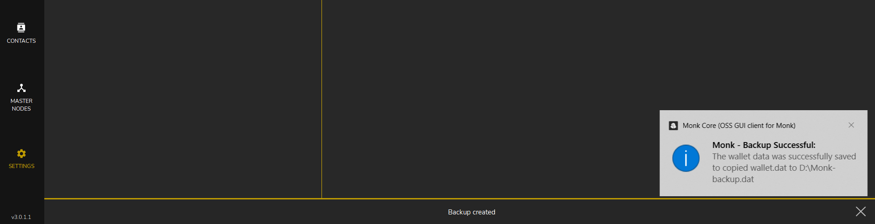

If in case you need to restore your backup, the name to use will be "wallet.dat"